# Create SampleServlet that extends

SlingAllMethodsServlet and registers it using resourceType

**Steps:**

1. **Create the Servlet class**:

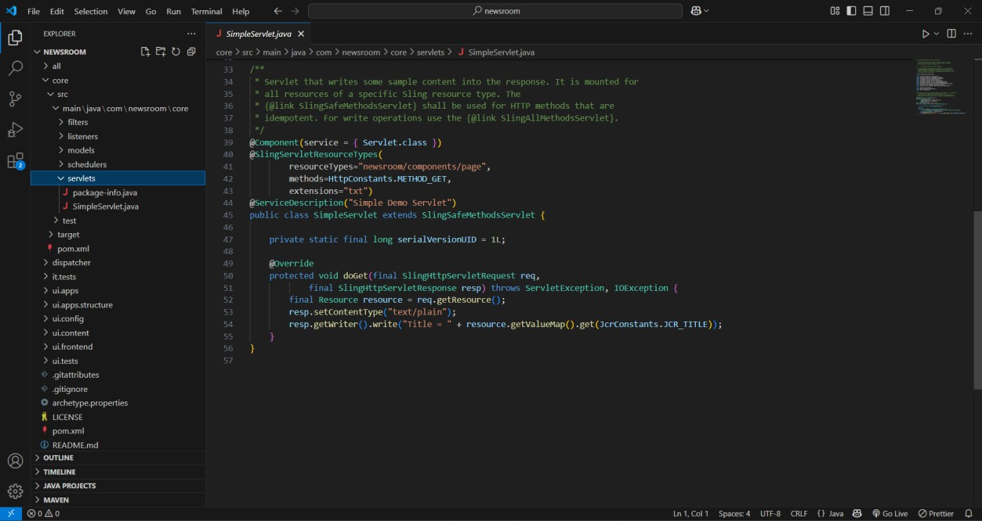

# Create CreatePageServlet that extends

SlingSafeMethodsServlet and registers it using path

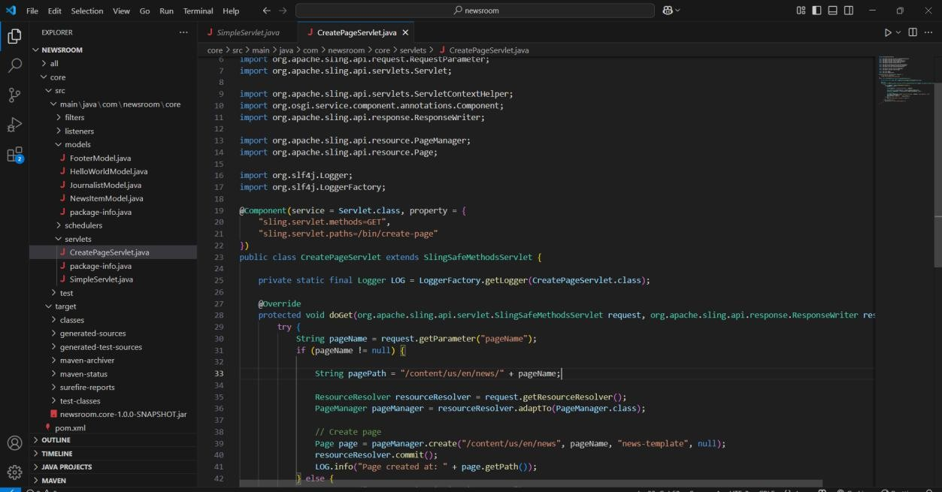

* + This servlet is registered to handle **GET requests** at /bin/create-page.
  + It takes a **pageName** parameter, creates a page at

/content/us/en/news/{pageName} using **PageManager**.

* + The **PageManager** API is used to create the page.
  + Logs the newly created page path after creation.

# Take Page Name from User and Create Pages in AEM Using Above Servlet

To create pages dynamically, you’ll use the CreatePageServlet. You can test it by accessing the servlet via the URL like this:

<http://localhost:4502/bin/create-page?pageName=myNewPage>

The **pageName** is passed as a parameter in the **GET request**. This will create a new page at /content/us/en/news/myNewPage.

# Use PageManager APIs for Above Task

The **PageManager** API is used in CreatePageServlet to create pages dynamically. In the servlet, PageManager.create() method is used to create a new page under the specified parent path (/content/us/en/news).

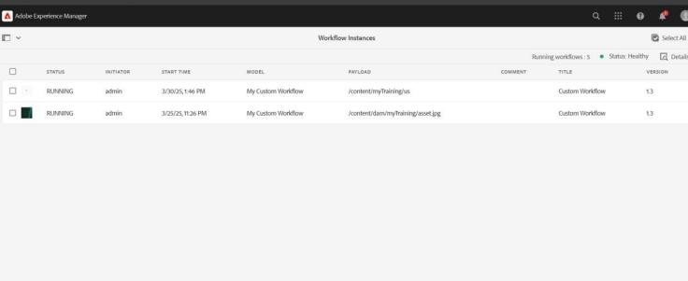

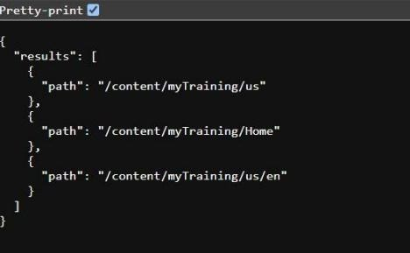

# Create SearchServlet to Search the Content Using PredicateMap

The Query Builder API is used to search content in AEM. We will create a servlet that uses PredicateMap to query the repository for content (pages).

